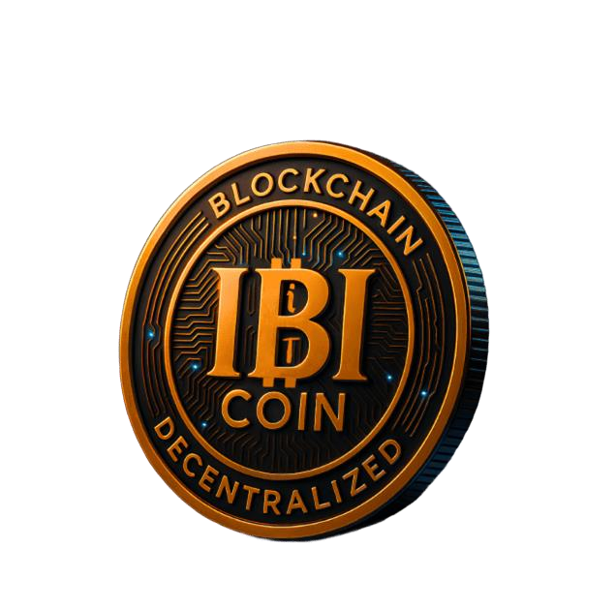

IBITIcoin (IBITI)
Whitepaper v2.0 – 2025
Contract (BSC): 0x47F2FFCb164b2EeCCfb7eC436Dfb3637a457B9bb
Network: BNB Smart Chain (BEP-20)
Decimals: 8
Website: https://ibiticoin.com

1. Introduction
IBITIcoin (IBITI) is a live cryptocurrency on BNB Smart Chain designed as the core asset of a modular DeFi ecosystem. The project combines:
- a BEP-20 token with dynamic fee logic,
- staking with lock-ups,
- NFT-based discounts and utilities,
- basic on-chain governance (DAO primitives),
- optional modules for buybacks, token sales and cross-chain expansion.
This document describes the current deployed architecture of IBITIcoin.
It replaces earlier, outdated documents that referenced old sale phases and legacy deployments.
IBITI is already trading in the IBITI/USDT pool on PancakeSwap v2.
There is no active ICO, IDO or presale operated by the team at the time of this document.

2. Vision & Goals
IBITIcoin is not intended to be “just another memecoin”, but a utility-driven digital asset that can:
- serve as a base token for staking and long-term holding,
- power NFT discount mechanics and gated utilities,
- provide a governance layer for protocol decisions,
- connect to future products and chains through modular smart contracts.
Key principles
- On-chain logic first. Core behaviour (fees, staking, NFTs, DAO) is implemented directly in smart contracts.
- Configurable, not frozen. Parameters can be updated by the owner / DAO, while the rules remain transparent on-chain.
- Transparency. Treasury balances, liquidity, staking and vesting are visible on BscScan and in open-source repositories.

3. Architecture Overview
IBITIcoin is built as a set of Solidity contracts that interact with each other:
- IBITIcoin.sol – main BEP-20 token (ERC-20 compatible, ERC20Votes).
- FeeManager.sol – configurable engine for buy/sell fees.
- StakingModule.sol – lock-up staking for IBITI holders.
- IBITINFT.sol & NFTDiscount.sol – NFT collection and discount logic.
- TeamVesting.sol – long-term locked allocations for the team and contributors.
- BuybackManager.sol – optional automated buyback logic for treasury.
- DAOModule.sol – simple on-chain proposal & voting module.
- BridgeManager.sol – hooks for potential future cross-chain bridges.
- PhasedTokenSale.sol & NFTSaleManager.sol – sale infrastructure (currently inactive).
All contracts are verified on BscScan and published under an open-source license for review.
Brand assets (name, logo, token symbol, NFT artworks) remain proprietary to the IBITIcoin project.

4. IBITI Token

4.1 Basic parameters
- Name: IBITIcoin
- Symbol: IBITI
- Decimals: 8
- Standard: BEP-20 (ERC-20 compatible)
- Max supply: 100,000,000 IBITI (100M, 8 decimals)
- Chain: BNB Smart Chain
The full max supply is minted at deployment to the treasury / founder wallet.
There is no additional minting beyond this cap.

4.2 Treasury-driven model
Instead of hard-coding allocations in the token contract, IBITI uses a treasury-driven model:
- The treasury wallet initially holds the total supply.
- From there, tokens can be moved to:
  - DEX liquidity pools (e.g. IBITI/USDT on PancakeSwap v2),
  - the StakingModule (reward pool),
  - TeamVesting (long-term locks),
  - ecosystem grants and partnerships,
  - DAO / governance reserves,
  - buyback and other technical modules.
Every movement is visible on-chain and can be audited by anyone.

4.3 Fee logic (FeeManager)
Transfers that involve liquidity pairs can be charged configurable fees via FeeManager.
This allows:
- different base fees for buys and sells,
- optional adjustments based on:
  - user status or holding period,
  - staking status,
  - NFT discounts,
  - volatility tiers or other risk metrics.
Fee destinations (treasury, buyback, etc.) and exact values are parameters, not hard-coded in this document.
The live contracts on BscScan are always the source of truth.

5. Token Economics

5.1 Design framework
The following ranges describe the intended structure of the 100M IBITI supply.
They are strategic guidelines, not a binding promise:
- Liquidity & market making: ~25–35%
- Staking rewards & incentives: ~25–35%
- Treasury & ecosystem development: ~20–30%
- Team & long-term contributors (vested): up to ~10–15%
- DAO & safety reserves: remaining portion
Actual live balances can be checked at the token address and related contract addresses
(treasury, staking, vesting, etc.) on BscScan.

5.2 No active sale phases
Earlier versions of the architecture included a phased token sale.
In the current deployed version:
- there is no active ICO, IDO, presale or public sale run by the team;
- PhasedTokenSale exists as a contract but is inactive and holds no user funds;
- most users obtain IBITI via the IBITI/USDT pool on PancakeSwap v2.
Any future sale or offering would be announced explicitly on ibiticoin.com and official social channels
and may require separate legal and regulatory review.

5.3 Circulating supply
Because all tokens were minted at genesis, “circulating supply” is defined economically:
- Circulating: tokens in DEX liquidity, regular user wallets, unlocked contracts.
- Non-circulating: treasury reserves, vesting contracts, locked staking rewards, DAO reserves.
Third-party trackers can provide estimates; users are encouraged to verify large allocations and locks directly on-chain.

6. Staking & Incentives

6.1 StakingModule
The StakingModule enables users to lock IBITI for predefined periods in exchange for rewards.
Key mechanics:
- multiple lock periods (e.g. 1–12 months), each with configurable reward multipliers;
- rewards paid in IBITI, funded from the dedicated reward allocation;
- optional penalties for early unstaking to protect long-term participants.
Reward rates (APR/APY) are configurable on-chain and should always be read from the live contract
or official UI, not from static documents.

6.2 NFT-linked benefits
Staking can be combined with NFTs:
- certain NFT rarities may increase staking rewards;
- long-term stakers can receive NFT drops;
- the NFTDiscount module exposes discount percentages that FeeManager can use
to reduce trading fees for NFT holders.
This creates a unified incentive system around holding + staking + NFTs.

7. NFTs & Discounts

7.1 IBITINFT collection
The IBITINFT contract hosts the official IBITI NFT series.
Each token is linked to IPFS metadata and mapped to a discount / rarity tier, such as:
1%, 3%, 5%, 7%, 10%, 15%, 25%, 50%, 75%, 100% discount tiers.

7.2 NFTDiscount logic
NFTDiscount.sol:
- reads a wallet’s NFT holdings,
- calculates the applicable discount percentage under predefined rules,
- exposes this discount to other contracts (FeeManager, sale modules, future utilities).
At present, public on-chain NFT minting and NFTSaleManager may be disabled;
NFTs function mainly as discount and utility keys while the ecosystem is being built.

8. Governance & DAO

8.1 Governance primitives
IBITIcoin uses ERC20Votes for governance-ready balances:
- holders can delegate their voting power,
- voting snapshots are taken per block,
- this integrates with DAOModule.
The DAOModule enables:
- proposal creation by users with sufficient voting power,
- voting “for” / “against” within a defined time window,
- basic quorum and threshold rules,
- marking proposals as executed once implemented (often via multi-sig in the early stages).

8.2 Decentralization path
Initially, IBITI governance is semi-centralized:
- core parameters (fees, staking config, module activation) are controlled by the founding team / multi-sig;
- the DAO is used for signaling, feedback and selected parameter changes.
Over time, more rights can be migrated from the team to DAO-controlled contracts,
subject to security and regulatory constraints.

9. Future Modules

9.1 BuybackManager
The BuybackManager contract is designed to allow the protocol or DAO to:
- allocate treasury funds (e.g. USDT, BNB),
- buy back IBITI on DEX,
- either burn the tokens or redistribute them as additional rewards.
Whether buybacks are active at any given time is a governance and treasury decision,
not a permanent rule.

9.2 BridgeManager
The BridgeManager contract prepares IBITI for potential multi-chain expansion:
- native IBITI on BNB Smart Chain remains the canonical asset;
- wrapped or mirrored tokens on other chains could be issued and burned
in coordination with BridgeManager and off-chain relayers.
No official IBITI bridge is operated at the time of this document.

10. Frontend & User Experience
The official website ibiticoin.com and its mirrors (GitHub Pages, Vercel) provide:
- project overview and documentation,
- a direct link to the official PancakeSwap IBITI/USDT pool,
- a staking dashboard for interacting with StakingModule,
- an NFT gallery with IBITI artwork and rarity tiers,
- an investment calculator (client-side, purely illustrative),
- links to official channels (Twitter, Telegram, Instagram, Facebook, LinkedIn).
All financial logic is defined only by smart contracts.
The website is a convenience layer; users should always verify contract addresses
and permissions independently.

11. Security & Risk

11.1 Contract security
IBITI contracts are built using OpenZeppelin libraries and common security practices:
- standard ERC-20/BEP-20 implementation,
- Ownable, Pausable, ReentrancyGuard patterns,
- no custom math libraries (Solidity 0.8+ overflow checks).
Nevertheless, any on-chain system carries risks, including:
- undiscovered bugs or vulnerabilities,
- governance misconfiguration,
- oracle or liquidity manipulation.
Users interact with the protocol at their own risk.

11.2 Operational security
The team aims to:
- store privileged keys on hardware wallets and multi-sig where feasible,
- minimize the number of privileged addresses,
- communicate major changes (fees, rewards, migrations) transparently,
- separate treasury, liquidity, staking and vesting funds.
External audits and reviews are planned, but no audit can guarantee absolute safety.

12. Legal Disclaimer
IBITI is a digital token that may provide utility within the IBITIcoin ecosystem.
It is not a share, security, debt instrument or guaranteed investment product.
Nothing in this document, on the website or in social channels constitutes
financial, legal or tax advice.
Token prices are highly volatile. There is no guarantee of profit, return or liquidity.
Regulatory treatment of digital assets differs across jurisdictions and may change over time.
Each user is responsible for complying with applicable laws, including tax obligations.
Smart contracts and blockchain infrastructure are experimental.
Exploits, bugs or unforeseen issues may lead to partial or total loss of funds.
By interacting with IBITI contracts or acquiring IBITI tokens, users acknowledge these risks
and accept full responsibility for their actions.

13. Licensing & Intellectual Property
All smart-contract code in the IBITI repositories is released under the MIT License (see LICENSE).
The IBITIcoin name, ticker, logo, website content and NFT artworks are proprietary to the IBITIcoin project and are covered by separate documents:
- LICENSE_TECHNOLOGY.md
- LICENSE_OVERVIEW.md
Third-party trademarks and brand names mentioned in this document belong to their respective owners.

14. Contacts
Project: IBITIcoin (IBITI)
Website: https://ibiticoin.com
Email (general): info@ibiticoin.com
Founder / CEO:
Volodymyr Podkorytov
Email: reker198079@gmail.com

